**Software Requirements Specification**

**for**

**one to many sharing application**

**Version 1.0 approved**

**Prepared by Manohar Mallela**

**18/09/2016**

**Table of Contents**

**Table of Contents**

**Revision History**

**1. Introduction**

1.1 Purpose

1.2 Document Conventions

1.3 Intended Audience and Reading Suggestions

1.4 Product Scope

1.5 References

**2. Overall Description**

2.1 Product Perspective

2.2 Product Functions

2.3 User Classes and Characteristics

2.4 Operating Environment

2.5 Design and Implementation Constraints

2.6 User Documentation

2.7 Assumptions and Dependencies

**3. External Interface Requirements**

3.1 User Interfaces

3.2 Hardware Interfaces

3.3 Software Interfaces

3.4 Communications Interfaces

**4. System Features**

4.1 Geo-Lock

4.2 Network Lock

4.3 Password Lock

**5. Other Nonfunctional Requirements**

5.1 Performance Requirements

5.2 Safety Requirements

5.3 Security Requirements

5.4 Software Quality Attributes

5.5 Business Rules

**6. Other Requirements**

**Appendix A: Glossary**

**Appendix B: Analysis Models**

**Appendix C: To Be Determined List**

**Revision History**

|  |  |  |  |
| --- | --- | --- | --- |
| **Name** | **Date** | **Reason For Changes** | **Version** |
|  |  |  |  |
|  |  |  |  |

# **1. Introduction**

## **Purpose**

We are creating this with the main purpose of requirements for the development and design of secured file sharing application. This is a document consists of the current requirements of the project as per the understanding of the project by the project team. This document is used by designers ,programmers, testers and others during the maintenance and development of the software. Careful understanding will ensure that requirements of the project are fulfilled and expected to deliver high performance and consistency.

## **Document Convention:**

We have used TIMES NEW ROMAN, where the Header size is 18 which is BOLD, Sub-heading size is 14 and the remaining text size is 12.We have taken some Priorities for the Document Conventions .

* To highlight any text in the document we have used text size is 14 with Bold Italic fonts.
* Features of the application are indicated by ★

## **Intended Audience and Reading Suggestions**

Our intended audience mostly is students but it can be any one. This document is read by the development team, documentation writers, admin and our users may review the document to learn about the project and to understand the requirements and will give some suggestions if needed. Developers gain advantage with the knowledge of SRS.

## **Product Scope**

This application gives an idea of file sharing in which the creator of a file is, by default, its owner. The owner can regulate the public accessibility of the file or folder.Files will be stored in Microsoft Azure storage services.The owner may also set an access level for regulating permissions.This app lets the user protect and share your files people based on our state of the art Network Lock and Geo-Lock.The access keys gained will last not more than 3 days..

There are 4 types of locks by which the user can choose according to his requirements.

* Geo-Lock
* Network Lock
* Password
* None

This application does not give access to the other users without owner’s permissions

## **References:**

-This application can be used for smartphones ,and computers also.

-Uses Azure storage services for storing files. For more Information about

Azure visit the link - <https://azure.microsoft.com/en-in/services/storage/>

-Directory of Azure - <https://azure.microsoft.com/en-us/services/>

-Official website - <https://azure.microsoft.com>

- Compatible with smartphones with Windows,Android operating system and PC’s having windows Version 8 - 10.0 installed.

- Compatibility is not guaranteed for devices without GPS capabilities.

- Compatibility information may be changed at any time(In upcoming updates).

- Information current as of September 19, 2017

# **2.Overall Description**

## **Product Perspective**

We designed this software to handle the protection & privacy of data.

* The project is all about how we secure data from other clients and maintain the data sharing between various clients.
* How to restrict the users from accessing the files.
* Owner(User) can apply the lock according to the requirements.

## **Product Functions:**

* No login required .
* User data is stored in the database.
* All the list of keys are stored in local area memory.
* User can add any file which he wants to share with others.
* There is no restriction for users as any no.of users can access file with valid access key and access criteria(Location,Network).
* The files that are shared can be displayed with the name of the user and date.. User can select all files or a single file at once to copy files in his

local memory area.

## **User Classes and Characteristics:**

* As the user Files are stored in azure storage services, sharing and data flow is taken care by REST API’s.
* Access keys and the history of the user is stored in the database.
* Now a user can add files for sharing and apply lock according to the requirements.
* A user can download files from app to his local memory area.

## **Operating Environment**

Client:

|  |  |
| --- | --- |
| Processor | Any |
| HDD | Any |
| RAM | Any |
| OS | Windows(8.1 - 10.0),Android 4.4 – 6 |

- Not compatible for linux and IOS operating systems.

## **Design and Implementation Constraints:**

* Server capacity gives you the idea that how many users can access to control network traffic . As the number of users increases the network traffic also increases and hence the server becomes slow. The constraint at the designing time is that users may keep their shared data in Server’s memory for a long time so Memory must be sufficient for this case.
* You get started with 5000GB free cloud storage space.
* It's easy to manage the privacy settings of our profiles,but if we don’t utilize it carefully,it could result to give access to the unauthorized users.
* All videos and image files that are stored via Google Drive must be downloaded each time they're accessed, which may be time consuming.
* The current version of the application does not support Linux editions,IOS.

## **User Documentation:**

* Documentation to the users about the configuration and usage of the system should be clear.
* The documentation provided should be clear enough to act as the first line of support for any problem.
* The documentation must include details regarding the knowledge of set-up,

configuration, maintenance, on-going management and error recovery procedures.

## **Assumptions and Dependencies:**

* This software doesn’t work on all platforms. .
* This depends on Azure cloud services for storing the files.
* The key generated will be expired after 3 days for security purposes.So after after 3 days if user want to access the file he need to reupload the file.

# **3.External Interface Requirements**

## **User Interfaces**

There are four primary elements on the main window.

* In windows, primary navigation is provided on the top of the

Screen and a list of graphical links.

* Buttons for sending and receiving a file.
* Error messages like Connection error and file Upload error will be displayed like popups.
* In the keys list the user knows all the keys of past 30 days.

## **Hardware Interfaces**

* Compatible with smartphones with Windows, Android OS and PC’s having Windows Version 8 - 10.0 installed.
* It’s not guaranteed on devices without GPS service as our primary feature is GEO-LOCK.
* The user can download the file even when the device is offline..
* Endless limit for size of the files.

## **Software Interfaces**

The user can download after gaining access to the file. If the owner applies Geo-lock the application verifies location by the GPS location service to gain the access.

If the owner applies Network lock the application verifies the SSID and gives access to the file. If the owner applies a password based lock the user has to enter the key which will be unique provided by the application.

## **Communications Interfaces**

* File Service allows storing and access of data on the cloud using theSMB protocol.

* **SMB:**(reference **-** <https://en.wikipedia.org/wiki/Server_Message_Block>)

Server Message Block(SMB), one version of which was also known as Common Internet File System(CIFS) operates as an application-layer network protocol mainly used for providing shared access to files, printers, and serial ports and communications between nodes on a network. It also provides an authenticated communication mechanism.

# **4.System Features**

* **Geo-Lock** is a form that can be accessed where access to content is restricted based on the user's geographical location. In a geo-lock , the user's location is calculated usingGPS techniques and co-ordinates, by this we can send the file using geographical location.

* **Network Lock** is a technical to restrict the access of the files to specific networks.

* **Password Lock** is used to protect a file with a unique password generated by the application.

4.1.2 **Stimulus/Response Sequences**

* If a user wants to share a file , he has to select the file and can upload the file & apply any of the locks described above.
* The key is saved in the keys list.
* The receiver has to enter the valid key in order to access the data to get access(password,location,network).

4.1.3 **Functional Requirements**

* The key must be expired after 30 days after key is generated

**Use Case Diagram**

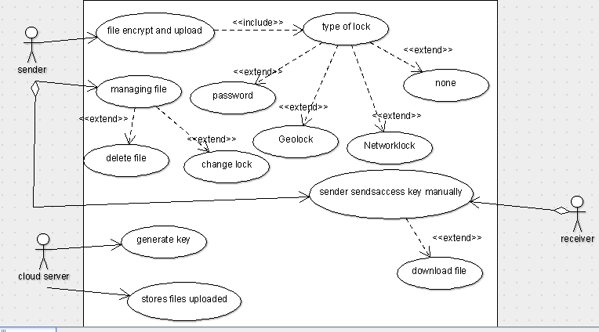

**Non-functional Requirements**

* **Performance Requirements**

We have made our application user friendly based. The application ensures to avoid confusion to the users. We have given our best UI to the users to have a fresh experience and can be accessed without any special knowledge. It also gives freedom for developers as it is done in Microsoft Azure.

* **Safety Requirements**

There is no chance of data loss as each and every data is backed up in Microsoft Azure through encryption. There can be no other chance for damage or harm unless you share the disclosed information(Security keys) with others.

* **Security Requirements**

This is a hassle-free application which doesn’t require any registrations. One can receive files even when the user is offline. Encryption is been done for files before being saved into servers for security purposes. After 30 days the access keys will be deactivated to achieve better security.

## **Authentication**

## No authentication required for the user to login.

## For the user to download a file he should have the valid access key and have specific requirement(location,network,password).

## **Software Quality Attributes**

## **Security:**

* + Access keys are encrypted and the user should have a valid access key and must fulfill the required criteria like location,network or password criteria to get access.
  + The files will be deleted 3 days after uploading and keys will expired after the three days.

## **Maintainability:**

We will be in constant implementation of the feedback once it will be released. We will try our level best to give the user a best UI and to avoid network traffic so that it lacks confusion and the server will be slow. Up gradation of the software depends on the feedback we receive.

## **Portability:**

This works both in smartphones and personal computers.

## **Reliability/Availability:**

## The availability of the system is a key requirement by nature. The candidate architecture must ensure failover capabilities. Targeted availability is 24x7: 24 hours a day, 7 days a week.

## **Business Rules:**

## **Team Members**

1. Chowdavarapu.sriker
2. Loga Prakash
3. Mallela Murali Manohar
4. K.Priyanka
5. M.Supraja Reddy

## **Division of work:**

|  |  |  |
| --- | --- | --- |
| S.No | Name of member | Work |
| 1 | K.Priyanka | Analysis(Functional and Nonfunctional Requirements). |
| 2 | M.Supraja Reddy,Manohar | Design (Architectural design, database design and interface design) |
| 3 | Ch.Sriker,Loga Prakash | Coding and Testing. |

# **Other Requirements**

* Reliability is very important.
* It has to overcome the Geo-Spoofing techniques
* Owner should have the capability of changing the lock type even after sharing the file.